IoT Based Safety Gadget for Child Safety Monitoring & Notification Solution Architecture

Team ID: PNT2022TMID49271

|  |  |
| --- | --- |
| Date | 12 October 2022 |
| Team ID | PNT2022TMID49271 |
| Project Name | IoT Based Safety Gadget for Child Safety Monitoring & Notification |
| Maximum Marks | 4 Marks |

**Team Leader:** Nageshwaran S

**Team members:** Manoj Kumar S

Sabari R

Sundar Naveen M

Raman T

**Solution Architecture Diagram:**

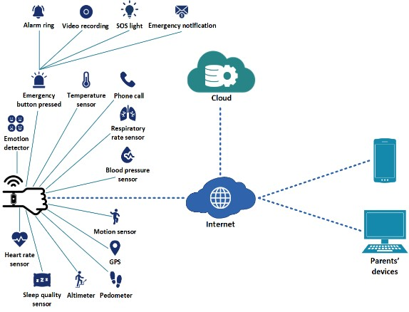

* An IoT based wearable smart band for children is proposed for child security purposes. The smart band is waterproof, chargeable and equipped with sensors.

* Heart rate sensor measures pulse rate and BPM. Sleep quality sensor obtains children’s sleep quality, cycle and positions. Altimeter detects changes in height and sense whether children are going down a slope or climbing stairs, thereby measuring calorie count.

* On the other hand, pedometer is used for counting steps. The motion sensor is applied to determines whether children are jogging or running. Blood pressure sensor used to measure blood pressure. In addition, the respiratory rate sensor detects breathing patterns and respiratory rate.

* Furthermore, the temperature sensor is used to detect body temperature. Besides, by using the emotion detector the emotional state, pressure and anxiety levels can be gained.

* Apart from that, this smart band contains GPS for tracking, identifying children’s location and setting geofences. Via the smart band, children can also contact parents. Emergency button, a feature in which will automatically record video and automatically call 4 emergency contacts when it is pressed.

* An alert message along with the video clip is sent to parents’ devices. The alarm and SOS light will be activated by parents through their devices.

* As the diagram shows, sensors are connected through the internet. They detect and capture different kinds of data.

* These collections of data will then be sent to the cloud over the internet for securely process, analyze, monitor, store, access and retrieve data remotely.

* After that, the information indicating children's status, along with reference values will be sent to parents’ devices with the app installed.

* If children’s actual data is not within the range of reference value, alert notification and some suggestions will be sent to parents’ devices.

* Also, when children leave geofences, notification will be sent to parents’ devices.